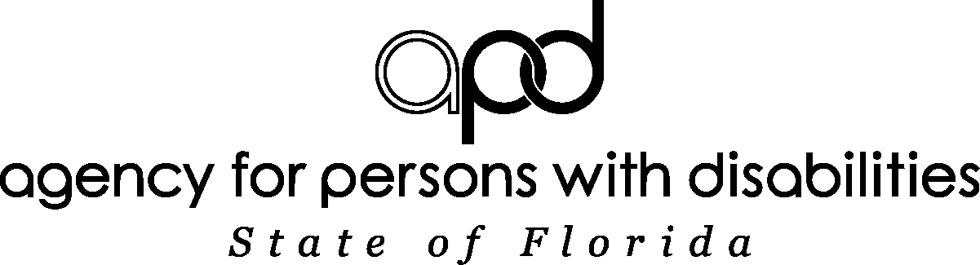 | AFFIDAVIT OF GOOD MORAL CHARACTER
State of Florida County of

Before me this day personally appeared who, being duly sworn, says:

I am an applicant for employment as a direct service provider or other individual screened pursuant to Chapter 435, Florida Statutes, and Section 393.0655, Florida Statutes, or I am currently employed as a direct service provider with:

By signing this form, I swear and affirm that I have not been found guilty of or entered a plea of guilty or nolo contendere (no contest) to, regardless of the adjudication, any of the following charges under the provisions of the Florida Statutes or under any similar statute of another jurisdiction. I attest that I have not been arrested for any of the following offenses and am currently awaiting disposition. I also attest that I have not been adjudicated delinquent for any of the following offenses, regardless of whether the records have been sealed or expunged.

I understand that I must acknowledge the existence of any criminal records relating to the following list of offenses. I understand that I am also obligated to notify my employer of any possible disqualifying offenses that may occur while employed in a position subject to background screening under Chapter 435, Florida Statutes. I further understand that the list stated below is subject to change and may include offenses that were not previously included.

NOTE: The following list of offenses has been updated August 1, 2010, and includes offenses specifically applicable to direct service providers under Chapter 393, Florida Statutes.
Offenses Relating to:
Sections: 393.0674 Felony offenses for the release or use of information from juvenile records of the Agency for Persons with Disabilities for any purpose other than screening for employment
393.135 Sexual misconduct with certain developmentally disabled clients or threats and/or coercion relating to reports or testimony of sexual misconduct
394.4593 Sexual misconduct with certain mental Health patients
409.920 Medicaid provider fraud
409.9201 Medicaid fraud
415.111 The filing or disclosure of information from reports of adult abuse, neglect, or exploitation of aged persons or disabled adults
741.30 Criminal acts that constitute domestic violence as defined in section 741.28, Florida Statutes
782.04 Murder
782.07 Manslaughter, aggravated manslaughter of an elderly person or disabled adult, or aggravated manslaughter of a child
782.071 Vehicular homicide
782.09 Killing of an unborn child by injury to the mother
Chapter: 784 Assault, battery, and culpable negligence, if the offense was a felony.
Sections: 784.011 Assault, if the victim of offense was a minor
784.03 Battery, if the victim of offense was a minor
787.01 Kidnapping
787.02 False imprisonment
787.025 Luring or enticing a child for an unlawful purpose
787.04(2) Taking, enticing, or removing a child beyond the state limits with criminal intent pending custody proceedings
787.04(3) Carrying a child beyond the state lines with criminal intent to avoid producing a child at a custody hearing or delivering the child to the designated person
790.115(1) Exhibiting firearms or weapons within 1,000 feet of a school
790.115(2)(b) Possessing an electric weapon or device, destructive device, or other weapon on school property
794.011 Sexual battery
794.041 Former offenses for prohibited acts of persons in familial or custodial authority
794.05 Unlawful sexual activity with certain minors
Chapter: 796 Prostitution
Section: 798.02 Lewd and lascivious behavior
Chapter: 800 Lewdness and indecent exposure
Section: 806.01 Arson
Sections: 810.02 Burglary
810.14 Voyeurism, if the offense is a felony
810.145 Video voyeurism, if the offense is a felony
Chapter: 812 Felony offenses for theft and/or robbery and related crimes
Sections: 817.034 Fraudulent acts through mail, wire, radio, electromagnetic, photoelectronic, or photooptical systems
817.234 False and fraudulent insurance claims
817.505 Patient brokering
817.563 Felony offenses for the fraudulent sale of controlled substances
817.568 Criminal use of personal identification information
817.60 Obtaining a credit card through fraudulent means
817.61 Felony offenses for the fraudulent use of credit cards
825.102 Abuse, aggravated abuse, or neglect of an elderly person or disabled adult
825.1025 Lewd or lascivious offenses committed upon or in the presence of an elderly person or disabled adult
825.103 Felony offenses for the exploitation of an elderly person or disabled adult
826.04 Incest
827.03 Child abuse, aggravated child abuse, or neglect of a child
827.04 Contributing to the delinquency or dependency of a child
827.05 Negligent treatment of children
827.071 Sexual performance by a child
831.01 Forgery
831.02 Uttering forged instruments
831.07 Forging bank bills, checks, drafts, or promissory notes
831.09 Uttering forged bank bills, checks, drafts, or promissory notes
843.01 Resisting arrest with violence
843.025 Depriving a law enforcement, correctional, or correctional probation officer means of protection or communication
843.12 Aiding in an escape
843.13 Aiding in the escape of juvenile inmates in correctional institution
Chapter: 847 Obscene literature
Section: 874.05(1) Encouraging or recruiting another to join a criminal gang
Chapter: 893 Drug abuse prevention and control if the offense was a felony or if any other person involved in the offense was a minor
Sections: 916.1075 Sexual misconduct with certain forensic clients and reporting requirements for such sexual misconduct
944.35(3) Inflicting cruel or inhuman treatment on an inmate resulting in great bodily harm
944.40 Escape
944.46 Harboring, concealing, or aiding an escaped prisoner
944.47 Introduction of contraband into a state correctional facility
985.701 Sexual misconduct in juvenile justice programs
985.711 Contraband introduced into detention facilities

ONE OF THE FOLLOWING STATEMENTS MUST BE SIGNED:
Under the penalty of perjury, which is a first degree misdemeanor, punishable by a definite term of imprisonment, not exceeding one year and/or a fine not exceeding $1,000 pursuant to ss.837.012, or 775.082, or 775.083, Florida Statutes, I attest that I have read the foregoing, and I am eligible to meet the standards of good character for this caretaker position. This means that I have not been found guilty of or entered a plea of guilty or nolo contendere (no contest) to, regardless of adjudication, any of the offenses listed above or any similar statute of another jurisdiction. I attest that I have not been arrested for any of the above offenses and I am not currently awaiting disposition of any of the above offenses. I also attest that I have not been adjudicated delinquent for any of the above offenses, regardless of whether those records have been sealed or expunged.

Signature of Affiant

OR
To the best of my knowledge and belief, my record may contain one or more of the foregoing disqualifying acts or offenses.

Signature of Affiant

OR

I swear or affirm that I am a licensed physician, licensed nurse, or other professional licensed and regulated by the Department of Health. I will be providing services that are within the scope of my licensed practice, and I am not subject to the screening provisions of section 393.0655, Florida Statutes.

Signature of Affiant

Sworn to and subscribed before me this ______ day of ___________________, ______

My commission expires |  | NOTARY PUBLIC, STATE OF FLORIDA

My signature, as a Notary Public, verifies the affiant’s identification has been validated by

